**Analysis on Ideal Locations for opening Indian Restaurants**

1. **Introduction**
   1. **Problem and Discussion of the Background**

In this project, we will try to recommend ideal locations to open restaurant, in specific Indian restaurants in Toronto city. Location of restaurant plays a significant role in business’s success. So, its crucial that we make right choice on deciding the location before we open up the business. Our research says, the restaurants near the competitors will not only give us access to their excess customers but also a chance to prove our products quality. So, we are going to look into the following key things to decide on the location. There are “Locations with one or more restaurants”, “Locations with no Indian restaurants” and “Locations which are close to city center as possible”. Our target audience are potential investors who are keen on opening up Indian restaurant in Toronto City.

By obtaining the data for the problem mentioned above, we are going to cluster neighborhoods and suggest the locations as a final result of our analysis.

1. **Data Description**

Based on the Borough, Neighborhood and the venue we will decide on potential locations to open restaurants. For example, If the location is near the city center with one or more restaurants and with no Indian restaurants in the vicinity then that’s the potential location we will suggest to the client.

We are going to collect the Toronto city’s postal codes, boroughs and neighborhood Latitude and Longitude from the URL “<https://en.wikipedia.org/wiki/List_of_postal_codes_of_Canada:_M>” and the ‘Geospatial_Coordinated.csv’ file which we already downloaded into local folder. The venues data in Toronto city and their respective Latitude and Longitude will be fetched from the Foursquare API.

1. **Methodology**

We have extracted all the data required for our analysis. And we have cleansed the data, our master data has following components like Postal Code, Borough, neighborhood, Latitude and Longitude.

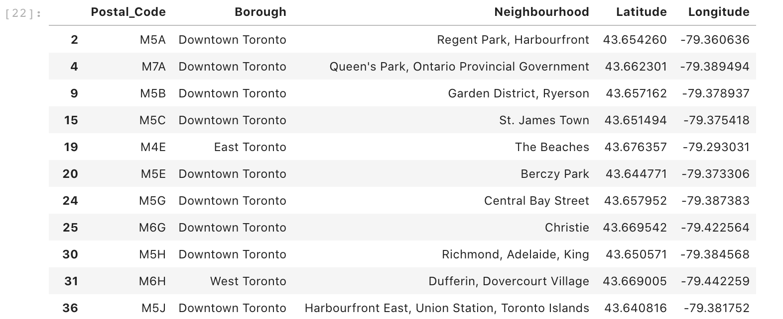

We have fetched the venues from the foursquare API with a limit of 100 venues within the radius of 500 meters from the neighborhood. We have fetched only the venues which comes under the category “food”. Once the data is fetched from the foursquare API, data is cleansed by removing unassigned boroughs and filtered only the restaurants from the venue category. And now we have joined the neighborhood data and the venue data together.

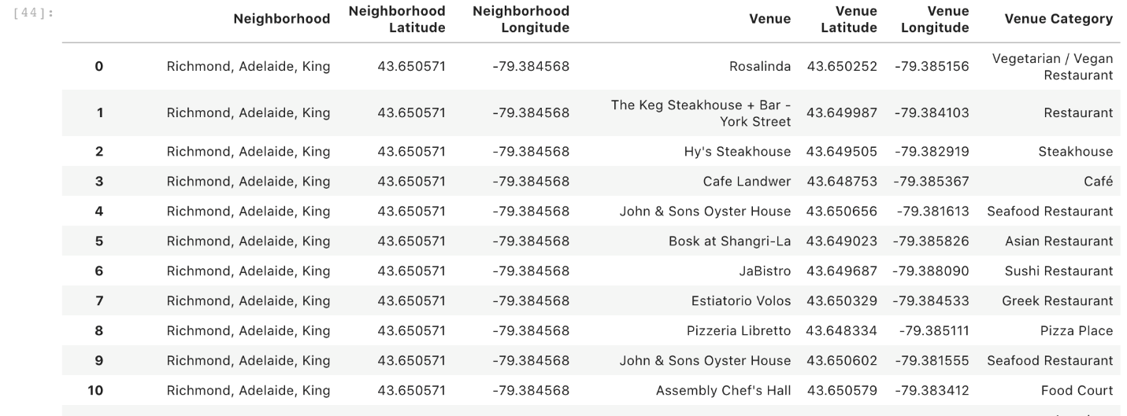

Now, it is time to visualize the restaurants in the Toronto city from the city center using the folium map.

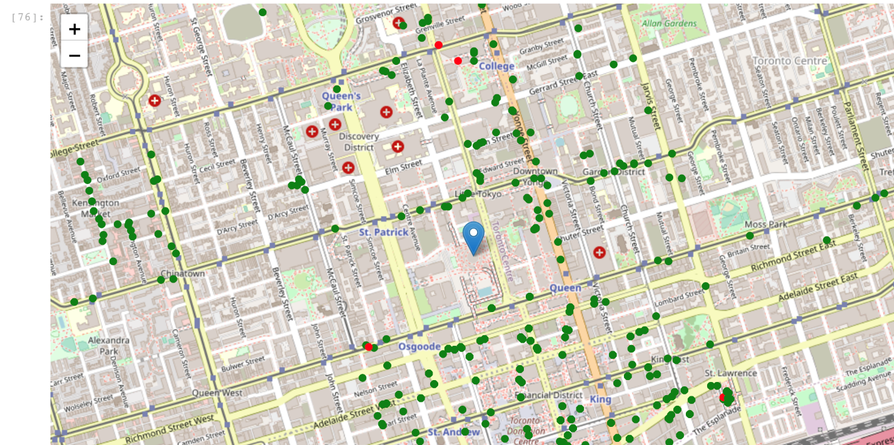

Let’s extract the restaurants which are less than 250 meters from the Indian restaurants.

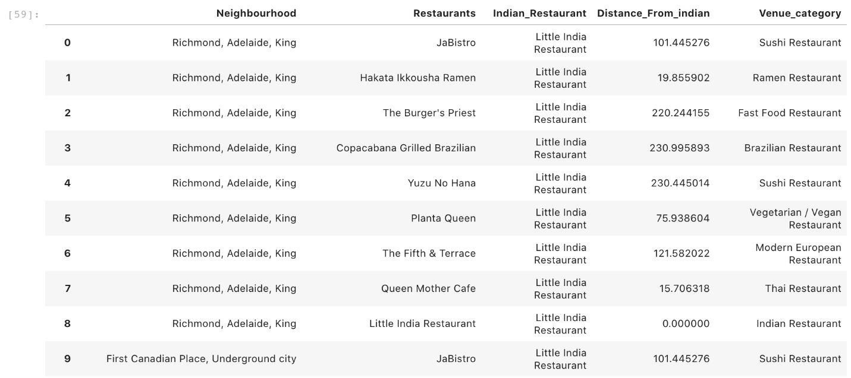

And we will exclude all the restaurants which are in less than 250 meters away from Indian restaurants along with the Indian restaurants itself. Now let us see the most frequented restaurants from the data we cleansed. And we will be able to see the restaurants which are more popular in the neighborhood.

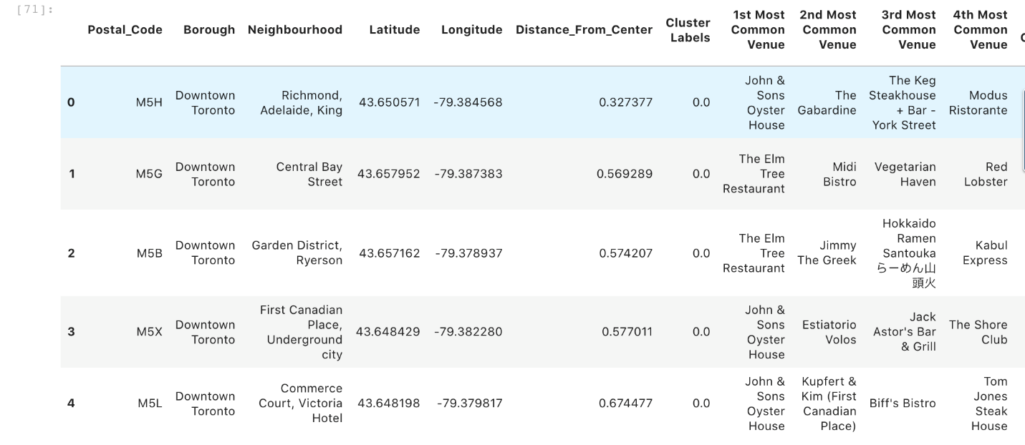

Finally, we will **cluster** the neighborhoods with **venues** which has **no Indian restaurants in 250 meters radius** along with **distance from city center** to suggest the locations for stakeholders. And we will visualize the same using the folium map.

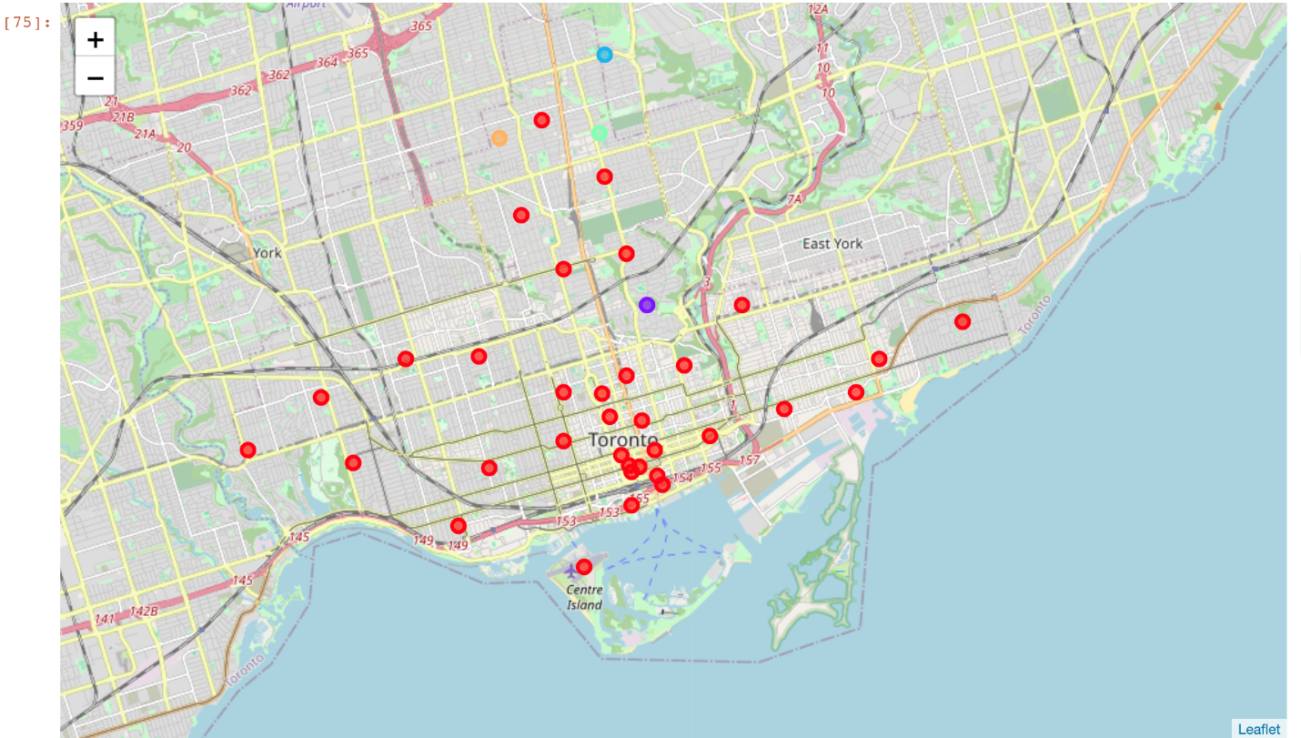

1. **Results**

Our goal is to analyze the locations for stakeholders which has no Indian restaurant with one or more restaurants and close to city center as possible. And we have achieved the same by fetching the source data from multiple sources and cleansing the data as required and we have visualized the same using folium map.

1. **Discussion**

Toronto city is well known for the cultural diversity. So does the restaurants in the city. There are a greater number of restaurants in the city from different cuisine. I have suggested locations based on certain conditions. But we might expect even better result from different perspective and using different method as well. An application in the near future studies dedicated for better insight to the stakeholders on this subject.

1. **Conclusion**

In this analysis, we have learnt the factors involved in evaluating and suggesting venues. This type of analysis reduces the likelihood of failure for any stakeholders. And it enforces the significance of data analysis in any decision-making skills.